EXPERIMENT 7

Name: Arav Desai | Roll No: 3
Subject: Programming and problem solving | Class/Batch: AIML A
Date of Performance: 14/8/2024 | Date of Submission:

Code

1.Write a program to display the following for the users specified number of lines.
*
**
***
****
*****
n lines
#include <stdio.h>

int main() {
int n;

printf("Enter the number of lines: ");
scanf("%d", &n);

for (int i = 1; i <= n; i++) {
for (int j = 1; j <= i; j++) {
printf("*");
}
printf("\n");
}

return 0;
}
Output

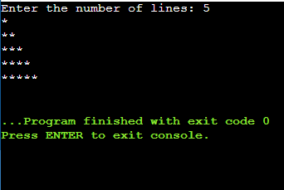

Code
II. WAP to display this partten as shown below
1
12
123
1234
12345
123456

#include <stdio.h>

int main() {
int n, i, j;

printf("Enter the number of lines: ");
scanf("%d", &n);

for (i = 1; i <= n; i++) {
for (j = 1; j <= i; j++) {
printf("%d", j);
}
printf("\n");
}

return 0;
}
Output

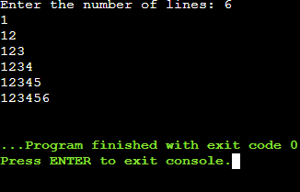

Code

- Write a program to disply the pattern as shown below
1
22
333
4444

#include <stdio.h>

int main() {
int n=4, i, j;

for (i = 1; i <= n; i++) {
for (j = 1; j <= i; j++) {
printf("%d", i);
}
printf("\n");
}

return 0;
}
Output

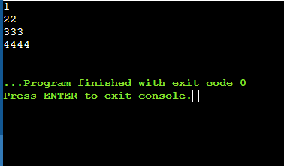

Code

- Write a program to print the pattern as shown below
1
2 3
4 5 6
7 8 9 10

#include <stdio.h>

int main() {
int n=4, i, j,a=1;

for (i = 1; i <= n; i++) {
for (j = 1; j <= i; j++) {
printf("%d",a);
a=a+1;
}
printf("\n");
}

return 0;
}
Output

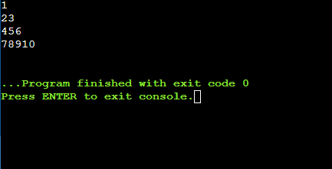

Conclusion

In conclusion, the recent exercises have provided an enriching exploration into the fundamental concepts of programming. Through crafting programs for generating patterns, determining if a number is prime, generating Fibonacci sequences, and implementing a basic calculator, we have deepened our understanding of loops, conditional statements, and user interaction in C programming. These programs illustrated practical applications of theoretical concepts, showcasing the power of programming to solve varied and interesting problems. This project underscored the importance of structured thinking and problem-solving, setting a solid foundation for more advanced programming endeavors. Through these tasks, we have not only enhanced our coding skills but also gained valuable insights into writing efficient, clean, and functional code.
Assessment

Timely Submission  (7) | Presentation  (06) | Understanding  (12) | Total  (25) | Sign

